MYTAXI SYSTEM

Use Case: <UC_USER_008– REQUEST ROUTES>

Version 1.0

Revision History

|  |  |  |  |
| --- | --- | --- | --- |
| Date | Version | Summary of Change | Author |
| 22 Jun, 2016 | 1.0 | Initial version | TEAM 01 |

Distribution for Review/Approval

|  |  |  |  |  |  |
| --- | --- | --- | --- | --- | --- |
| Name | Title & Company | Issue Version | Issue Date | Review Date | Approval Date |
| Doan Vo | BA Lead - BAC | 1.0 |  |  |  |

Contents

1 Introduction 4

2 Processes 5

3 Flow of Events 5

3.1 Basic Flow: 5

Basic Flow: <Login by Third party> 5

3.1.2 Basic Flow: <Login with email> 6

3.2 Alternative Flows: 6

3.2.1 Alternative Flows: < Login by Third party failure> 6

3.2.2 Alternative Flows: < Login by Email failure> 6

4 Business Rules 7

5 Special Requirements 7

6 Supplementary Information 7

7 Related Documents 7

# Introduction

|  |  |
| --- | --- |
| ID and Name | UC_User_008-Request Routes |
| Description | - Help users request their routes to system. |
| Actor | * Driver * Passenger |
| Relationships | Includes:   * Login |
| Pre-conditions | 1/ Successful login to the system  2/ Access to the screen Request routes. |
| Post-conditions | 1/ Users can select start root, end root  2/ Users can book their route at start time  3/ User will be received trip’s information such as: partner trip, trip lengh, payment,… |

# Processes

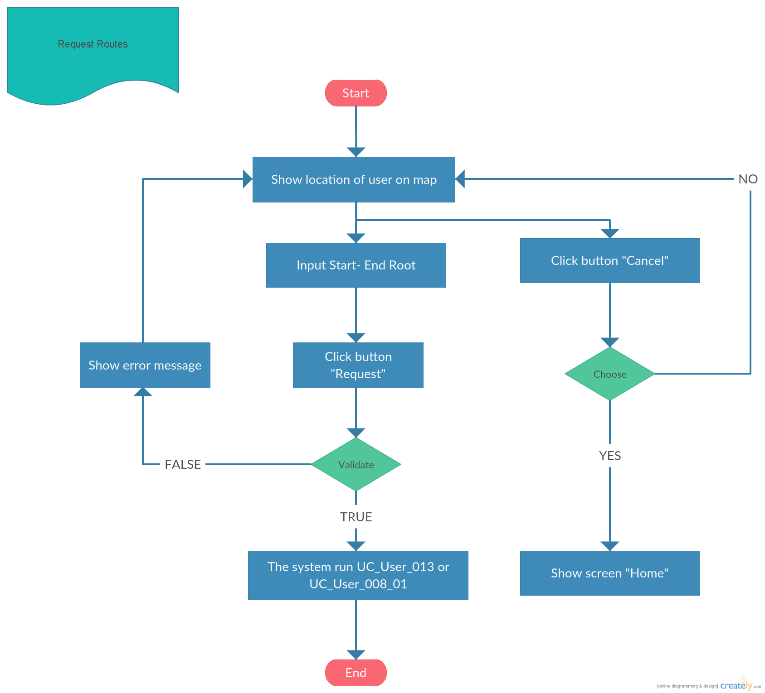

# Flow of Events

## Basic Flow: <Request Route>

|  |  |
| --- | --- |
| **Step** | **Description** |
|  | The actor access to the screen Request routes. |
|  | The system show screen “DETAIL ROUTE” |
|  | The actor select start root, end root |
|  | The system show trip’s information |
|  | The actor click button “Submit” |
|  | The system save trip into DB |

## Alternative Flows:

### Alternative Flows: <Request routes failure>

|  |  |
| --- | --- |
| **Step** | **Description** |
| 1 | Actor clicks “ Submit” button. Actor not login into system |
| 2 | The system will displayed the “Request routes” page with the error message “User not login into system” |
| 3 | The end |

## Exception Flows

N/A

# Business Rules

|  |  |
| --- | --- |
| **BR ID** | **Description** |
| BR1 | <Description, calculation logics, sample> |
| BR2 | <Description, calculation logics, sample> |
| BR3 | <Description, calculation logics, sample> |

# Special Requirements

<Only list out the non-functional requirements applied for this specific UC, not for the whole system. Normally it is performance requirement.>

# Supplementary Information

<Contain any additional materials that

* support to understand this use case better such as workflow, activity diagrams, data dictionary
* supplementary details for the completeness of this use case such as data specifications of entities used in the flows, message log
* golden data
* etc.

>

# Related Documents

<only needed if this document refers to many other documents, this section aims to give the readers a summary of all referenced documents>

|  |  |
| --- | --- |
| **When** | **Refer to** |
| <Purpose> | <Document ID – Name, storage location if possible> |